
a
Company
Logotype

Cone Beam Computed Tomography- Report



Porur Dental X-rays & CBCT

Patient Name : Mr. Ramaswamy | Date of Report : 27.06.2024
Age/ Gender : 70 years/ Male | Region of Interest : CBCT Maxilla
Referring doctor: Dr. Subramoniam. S | Indication : Implant assessment
Clinical Notes: Nil
PATIENT INFORMATION

CBCT- Maxilla provided
CBCT – IMAGE DETAILS

RADIOGRAPHIC INTERPRETATION

- Completely missing crown and root portion in relation to maxillary arch.
- Presence of hyperdense structures in relation to 13, 15, 22, 25 regions evident.
- The maxillary alveolar ridge is present with normal trabecular pattern.
- The nasal passage in relation to the right side is narrow compared to the left side. Deviated nasal septum towards the right side is evident.

IMPLANT ASSESSMENT

 | 11 region | 12 region | 13 region | 21 region | 22 region | 23 region
Sub-Crestal | 3.889 | - | - | 2.91 | 1.92 | 2.13
Mid- Crestal | 4.85 | - | - | 3.16 | 2.34 | 2.26
Distance between the alveolar ridge and Floor of the Nasal cavity (in mm) | 8.2 | 1.65 | 1.99 | 10.36 | 9.21 | 11.67

 | 14, 15 region | 16 region | 17 region | 24, 25 region | 26 region | 27 region
Sub-Crestal (in mm) | 5.85 | 4.97 | 5.15 | 4.92 | - | -
Mid- Crestal (in mm) | 6.77 | 5.58 | 5.93 | - | - | -
Distance between the alveolar ridge and floor of the maxillary sinus (in mm) | 6.29 | 6.51 | 7.39 | 2.31 | 1.8 | 2.17

RADIOGRAPHIC IMPRESSION

- Edentulous maxillary arch.

Kindly correlate with clinical findings


IMAGES FOR REFERENCE

RECONSTRUCTED PANORAMIC VIEW
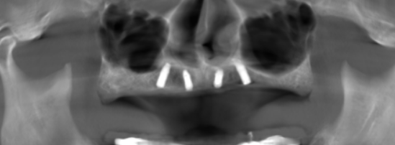

3-DIMENSIONAL VIEW

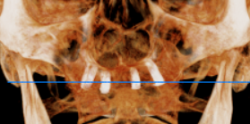

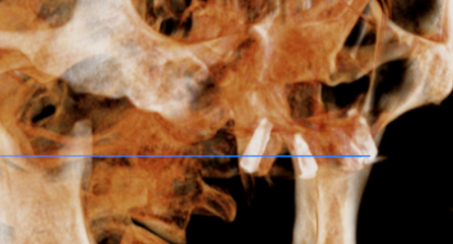
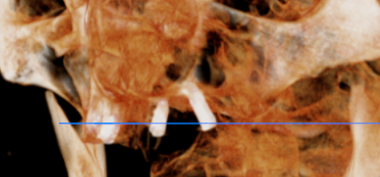

CROSS SECTIONAL VIEW

11 region | 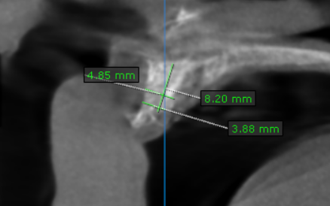
12 region | 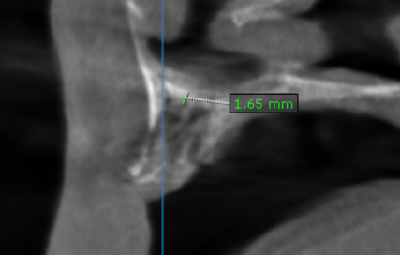
13 region | 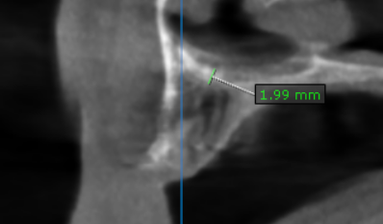
14, 15 region | 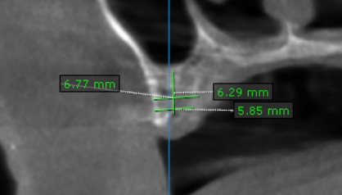
16 region | 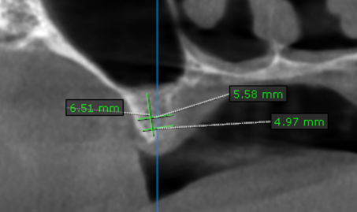
17 region | 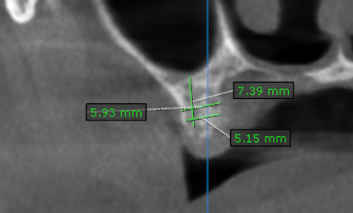
21 region | 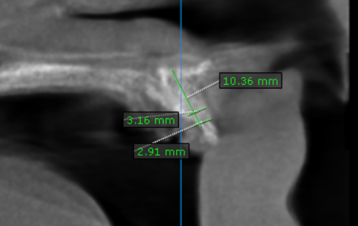
22 region | 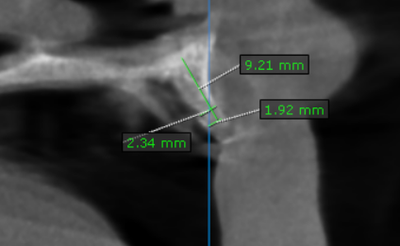
23 region | 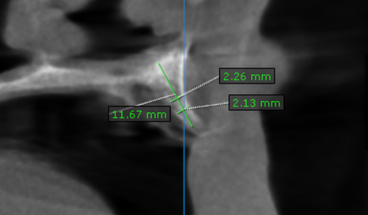
24, 25 region | 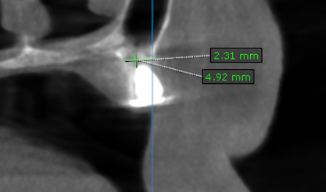
26 region | 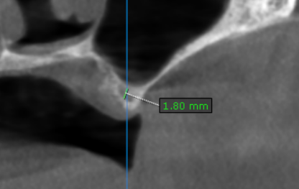
27 region | 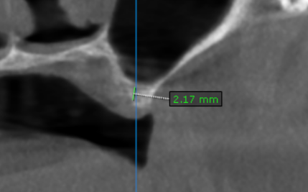

**** End of report ****

